**Introduction**

We received a complete dataset of shootings in the United States by Police Officers and the topic of racism came into play where people thought they were shot or killed because of the race of the victims. In this project, we will be analysing the entire dataset and its columns to determine if race, age, gender, whether the victim was armed or not and how they were killed. This will also show if the poilice officers were strapped with body cameras when the incident happened.

**Data Cleaning**

This was the first process we went through before perfoming the Exploratory Data Analysis. This process is where we go through the entire dataset to make sure there are no empty rows, columns or cells. We also make sure there are no null values. The dataset must be complete.

Since the entire dataset consisted of four thousand, eight hundred and ninety-five rows, goin through it row by row would be very difficult. We therefore wrote a code to run through the entire dataset to make sure there were no missing values. The function of the code was to drop rows that were empty and check if there were null values in the dataset. Furthermore, the code checks if there are duplicated entries and drops one of them when it is found.

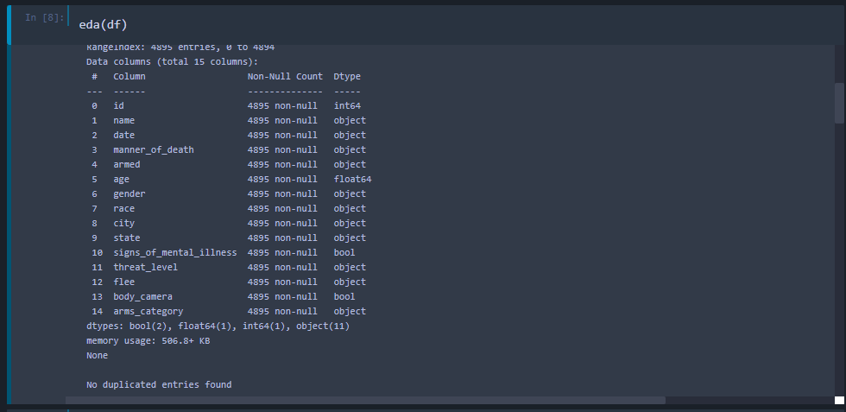

Fig. 1

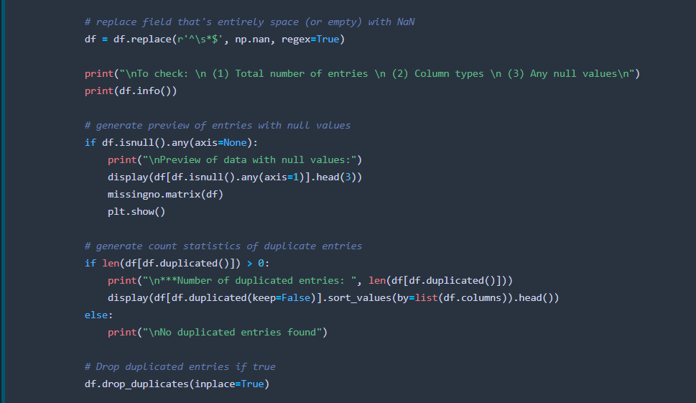

Fig. 2

In addition, we changed the values of all the ages to integers and not floating numbers because no one has a floating number as their age.



Fig. 3

**Exploratory Data Analysis**

Exploring the data, we tried to find out the unique value or columns and their corresponding count or frequency of the non-numeric data. This is what is termed as categorical data.

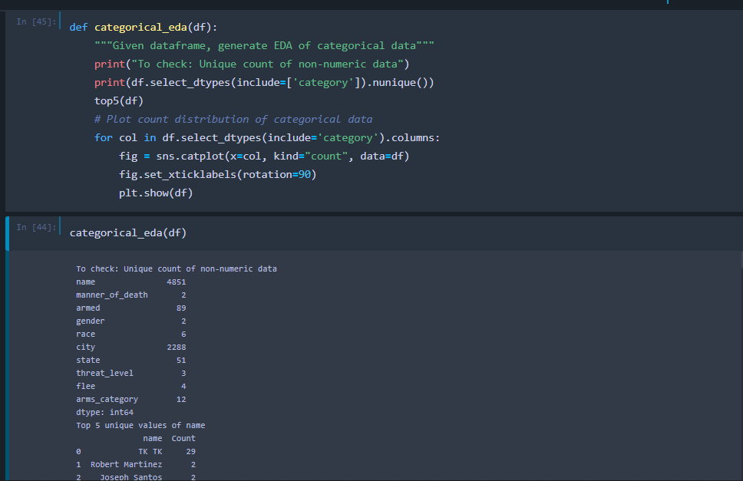

Fig. 4

This code and its output shows the unique non-numerical data from the dataset. The age column from the dataset contains numberical data but the name column from the dataset is made up on non-numerical data. The above figure shows how it is represented.

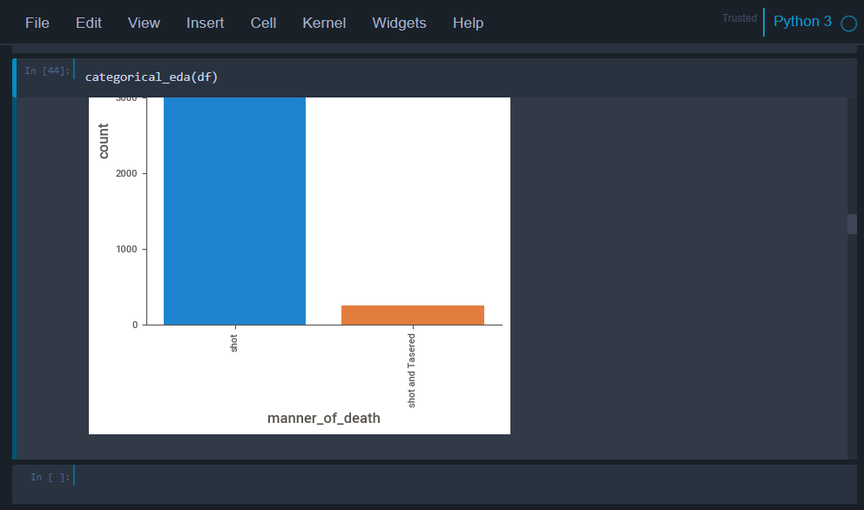

Fig. 5

Fig. 5 displays the manner of death and how the many people were killed in that manner. We can clearly see from the graph that the most of the people were killed with shot more. The other manner in which they died was being shot and tased at the same time.

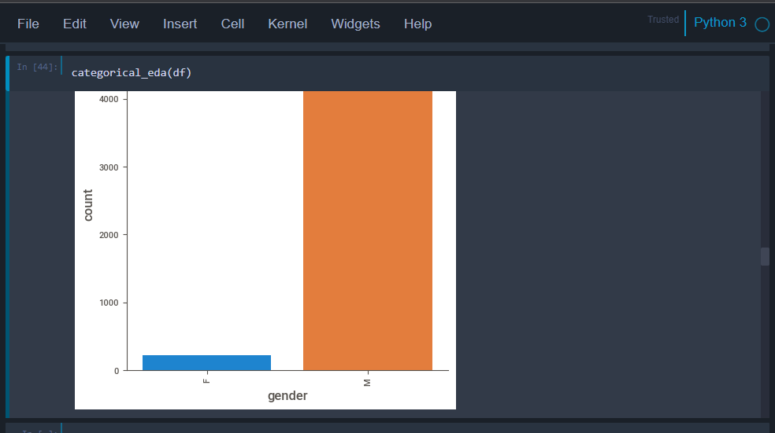

Fig. 6

In this graph, we can tell from it that Males were targeted the most and killed as compared to females.

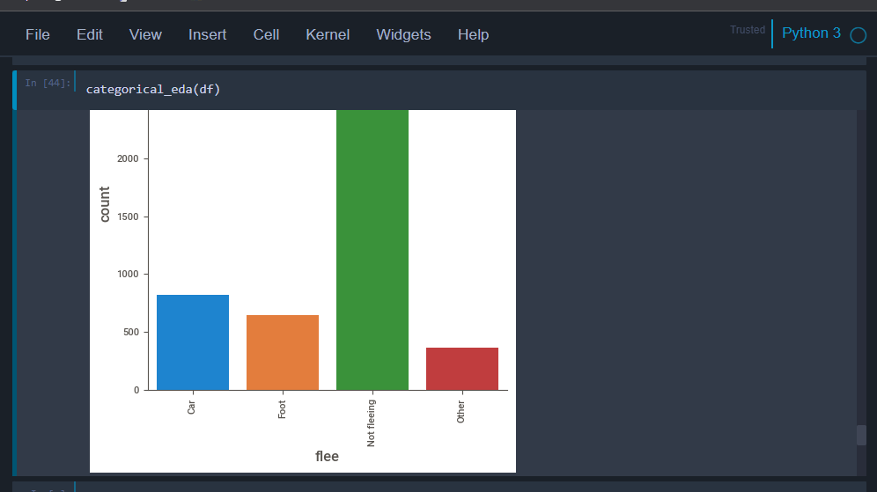

Fig. 7

This figure demonstrates the manner in which the victims were caught and killed. When we take a closer look at the graph, we notice that few of them were fleeing with the aid of something else, some of them were fleeing on foot when they were caught and killed and others were also fleeing in vehicles or cars. The most concerning aspect discovered was the fact that most of them were not fleeing when they were caught and killed.

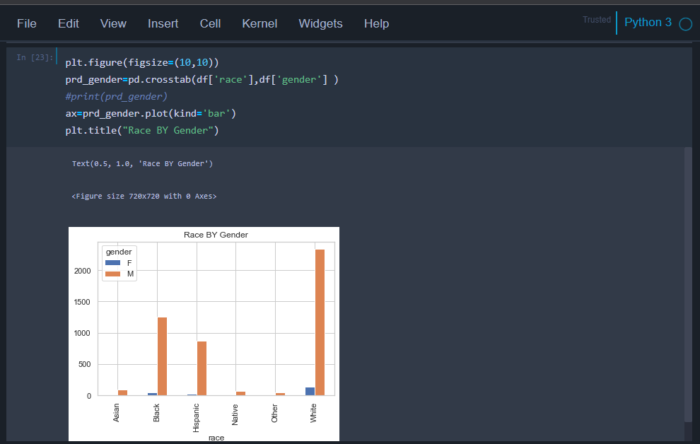

Fig. 8

This graph displays race by gender and the frequency with which they were killed. Most of those killed were males and they were also White. The next highest bar shows that male blacks are the most killed next to White males.